**The Geography of a rapid rise in mortality in England and Wales, 2014-15**

Mark Green1*, Danny Dorling2, Jon Minton3.

1 Department of Geography & Planning, University of Liverpool, Liverpool, UK.

2 School of Geography and the Environment, University of Oxford, Oxford, UK.

3 School of Social and Political Sciences, University of Glasgow, Glasgow, UK.

* Corresponding author. Address: Department of Geography & Planning, Roxby Building, University of Liverpool, Liverpool, L69 7ZT, UK. Tel: 0151 794 2854. Email: mark.green@liverpool.ac.uk.

**Abstract**

Since at least the early 1900s almost all affluent nations in the world have continually experienced improvements in human longevity. These were driven by falling mortality rates across all age groups, but initially mostly amongst the young (Garrett, *et al*., 2006). Using ONS mid-year population and deaths estimates for Local Authorities for England and Wales, we show that these improvements have recently reversed, hopefully temporarily. There have been especially high increases in mortality rates within the elderly, a group which we this choose to focus our analyses on. In England and Wales, we estimate that there were 39,074 more deaths in the year to July 2015 as compared to the year to July 2014 (32,208 of these additional deaths were of individuals aged 80+). Exploring changes in mortality rates by 5 year age band and sex, we demonstrate that these increases have been felt everywhere geographically; in poor and affluent areas, in rural and urban areas. We explore some possible explanations for the increases and find that few individual factors on their own appear able to explain the patterns we observe. The implications of our findings are profound given what has come before them which included several years of the population reporting worsening health. This, combined with the current political climate of austerity, and the size, scale and lack of spatial pattern in these changes in 2015 (particularly in comparison to previous years) suggests that something wider is occurring at the population level than simply a one-off event. Mortality rates had risen slightly in 2012 and 2013 for very elderly women – referred at the time as being the “canaries in the mine”.

**Keywords**

England and Wales; mortality; health geography; epidemiology; elderly.

**Introduction**

One of the great successes globally since the early 1900s has been the continued improvement of human longevity. For example, life expectancy at birth in England and Wales has increased by 28 years over the last 100 years (i.e. from 51 in 1910/12 to 79 in 2010/12) (ONS 2014). Developed countries passed through the epidemiological transitionwhere their disease profiles moved away from the majority of deaths being due to infectious diseases towards chronic illnesses being the most likely precursor to mortality(Omran 1971). While medical improvements have helped to treat ill health and disease, improvements in population health have been largely driven by better sanitation, education and general rising standards of living (Woolf et al. 2007). As a result, age specific mortality rates have been falling consistently throughout the 20th Century and beyond in all affluent countries (Minton et al. 2013), delaying ever longer the inevitable trip to the morgue.

The 2008 Great Recession saw worldwide economic decline on a scale not observed in the UK since the Great Depression that began in 1929. Many governments (including that of the UK) responded by cutting the size of the state under the assumption that lower public expenditure would lower public debt, leading to lower taxation (especially corporation tax) and so increased economic growth. Other countries such as Finland, France, Denmark, Norway, Sweden and Japan increased the proportion of their GDP spent on public services to mitigate the effects of GDP falling (see Figure 2 in Dorling, 2016a). The resulting changes to society in those countries that chose to cut public spending the most were all encompassing, affecting everyone (although some more than others). The only country to cut spending more than the UK was Ireland which consequently again experienced high rates of emigration (Dorling, *ibid*). In England and Wales, university students suddenly had to take on great debts to study (three times the pre-2012 levels), more affluent parents saw their child allowances withdrawn, but it was the services mainly used by poor people were cut most severely.

Given the widespread societal change, what does the geography of mortality look like in this new austerity society? In our study, we present evidence that longstanding mortality rate declines reversed between 2014 and 2015. We explore how these changes have occurred geographically, as well as examine possible correlates of these changes. To date there is only one other published study of this rise that finds a high degree of correlation in the cuts to income support and pensioner credits and mortality in the years up to 2013 (Loopstra *et al.* 2016). As yet no papers have been published on the further and faster rise in mortality that took place in 2015.

**Methodology**

We used mid-year population estimates data for England and Wales from the ONS[1]. Annual data on mid-year (data for 1st July to 30th June) population estimates for Local Authorities[2] are provided (n = 348, mean population size in 2015 was 166,337), and the dataset includes death counts as well. Data are supplied by sex and single year ages (5 year age bands were used to reduce small number issues). We focus mostly on old age mortality for the age bands 80-84, 85-89 and 90+ because at these ages mortality rates are greatest (i.e. patterns are less likely to influenced by chance), as is their dependence on health and social care services due to the risky burden of morbidity that inevitably comes with age. We calculate age-specific rates by sex for Local Authorities by year. To measure the relative change between years, we calculate the rate ratio (i.e. divide the two mortality rates – the more recent one by the later one). Age-specific rates were adjusted for any potential age-aggregation bias to account for whether differences between years were the result of differences in the composition of age bands or cohort effects[3] (Gelman & Auerbach 2016). Data for 2015 were not available for Scotland at a local level, although it has been reported elsewhere that national patterns were similar (ONS 2016b).

We defined six categories to summarise the extent of relative mortality differences by our sex-specific age bands. These six categories were arbitrarily defined, but were defined before we saw what they revealed based on cut-offs automatically provided by the software used. The results were so interesting that we have simply used these, but we believe that other choices would reveal similar patterns because the numbers of extra deaths that occurred in the year to July 2015 was so high. Note that a rise of 6.5% is one extra death for every 15 that usually occur and a rise of 15% is one extra death for just under every 7 that normally occur. Our categorisation divided up areas into the following hierarchical groups (i.e. areas belonged to only one category based on the ‘severity’ of their changes):

1. Three or more sex-specific age groups with a rate ratio of greater than 15% (i.e. 1.15)
2. Two sex-specific age groups with a rate ratio of greater than 15%
3. Three or more sex-specific age groups with a rate ratio in greater than 6.5%
4. Two sex-specific age groups with a rate ratio in greater than 6.5%
5. One sex-specific age group with a rate ratio in greater than 6.5%
6. None of the above.

Two explanatory factors for the relative changes in mortality were considered. The mid-year population estimates also included internal and international migration flow data by sex and five year age band. We compared these measures to the rate ratios to examine whether migratory patterns may help to explain changes in Local Authorities (e.g. the inflow of older unhealthy migrants returning from abroad). There is limited migration of these age groups, so we hypothesise that it is unlikely to explain any patterns. We also used the English Indices of Multiple Deprivation (IMD) 2015 Local Authority summary statistics to examine whether any changes were associated with social inequalities (n = 326). We do not include the Welsh Local Authorities (n = 22) in our analysis of deprivation since their multiple deprivation measures are different.

We used Geographic Information Systems (GIS) to visualise the spatial distribution of the rate ratio. Two types of maps are used to visualise our data: standard maps that are geographically correct, and cartograms whereby the size of areas are adjusted in relation to their population size whilst also maintaining topology (Tobler 2004). Both approaches present different geographies – one dictated by space, the other by people. Rate ratios were divided into quantiles based on all sex-specific age band values to allow for fairer comparisons when plotted together. Our geographical analysis was supplemented through calculating the Moran’s *I* coefficient (Moran 1950) which measures the extent of spatial autocorrelation (i.e. how spatially clustered the data are) to give us a formal measure of the existence of geographical patterns. Queen contiguity (order = 1) was used to define the spatial structure of the data (i.e. compare Local Authorities with all surrounding areas that share a common boundary in any direction). We also examine the association of rate ratio to our explanatory factors using Pearson’s correlation coefficient. Analyses were undertaken using QGIS, GeoDa, R and Microsoft Excel.

**Results**

*Relative changes in mortality rates in England and Wales, 2014-15*

Figure 1 presents the relative change (rate ratio) of mortality rates by age band and sex for England and Wales (2014-15). Deaths rose by 11.8% and 18.2% for males and females respectively who had survived to age 90; by 9.2% and 11.2% for those aged 85-89; and 5.7% and 9.3% for those aged 80-84. We estimate that if 2015 mortality rates had remained the same as 2014 rates, then we would have seen 39,074 fewer deaths in 2015. The majority of these excess deaths were above the age of 80 (an additional 32,208 deaths, equivalent to 82.4% of all additional deaths).

**Figure 1: Relative change of mortality rates by sex for England and Wales, 2014-15.**

Whilst the relative change in mortality rates increased with age, not all age groups saw increases. There were falls for infants and in adults aged 25-29. These falls reflect patterns observed such as declining car use (i.e. driving has become less affordable) during the period of austerity which may be having a positive effect on some aspects of population health (Stuckler et al. 2011; Minton et al. 2016). Furthermore the age 25-29 age group had the highest net international in-migration in the year to July 2015 of over 60,000 additional young and presumably very healthy people coming into England and Wales, mostly from the rest of the EU. When both relative risk and baseline mortality risk are considered together, the effects of rising mortality risks are greatest in people above retirement age, rising monotonically (females) or near monotonically (males) with age after the age of 65. The relative change in mortality rates was also higher for females for most ages (particularly the age group 90+). However, older men’s mortality rates had been improving faster than older women’s in the decade before 2010. This may have been due to more women taking up smoking in the 1970s. So it is possible that we would have seen that men were just as effected as women if we had compared the number of deaths which occurred to those that would have been expected to occur if the improvements of earlier years, and the improvements which continued in nearby countries, and been experienced in England and Wales.

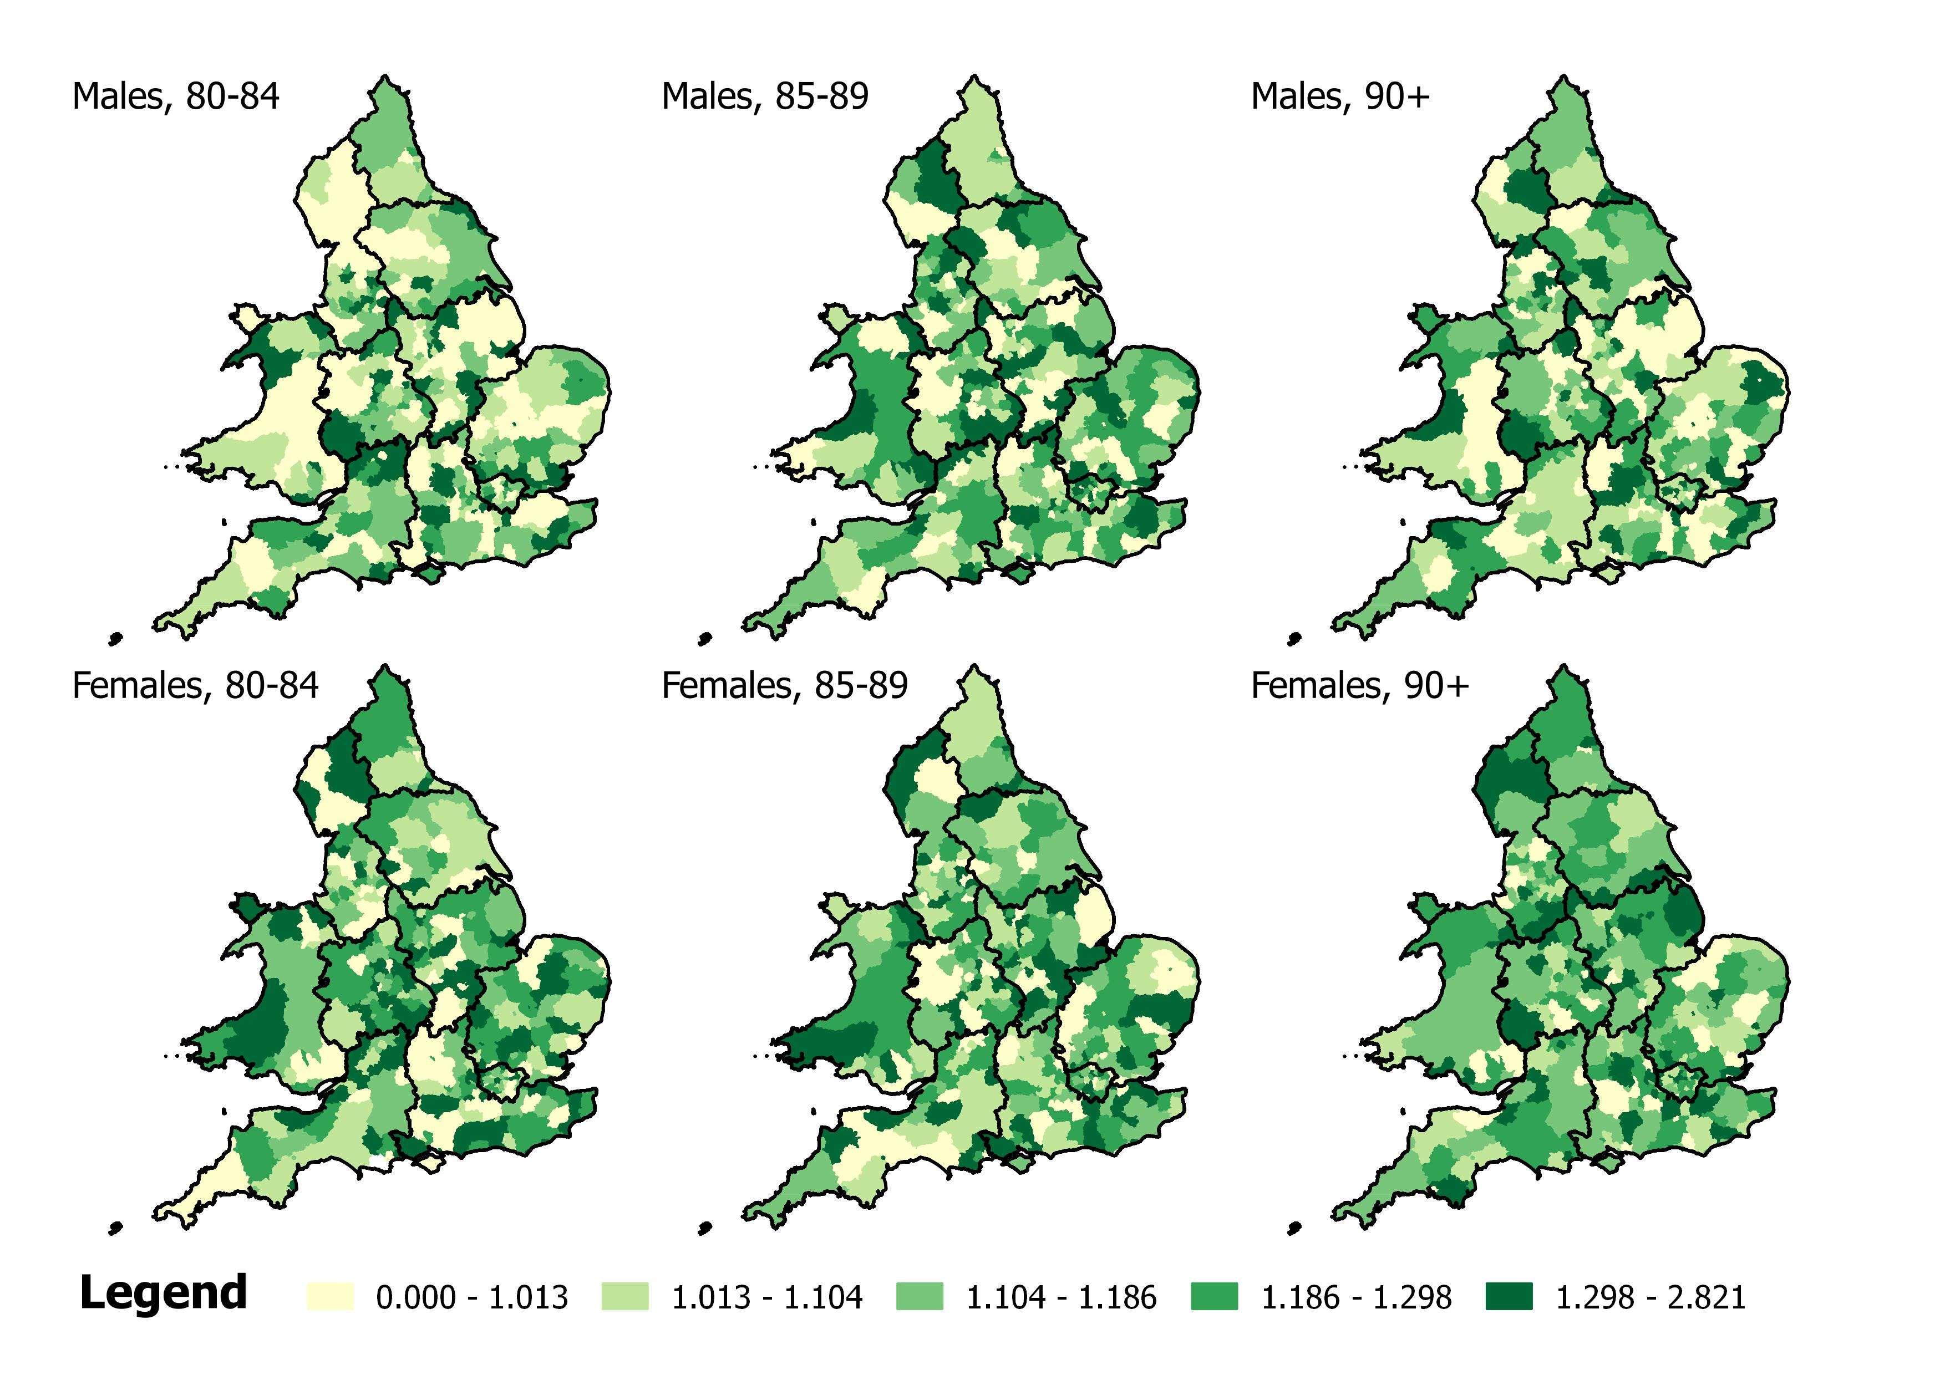

**Figure 2: The relative change in mortality rates by sex and age band for England and Wales, 2014-15**

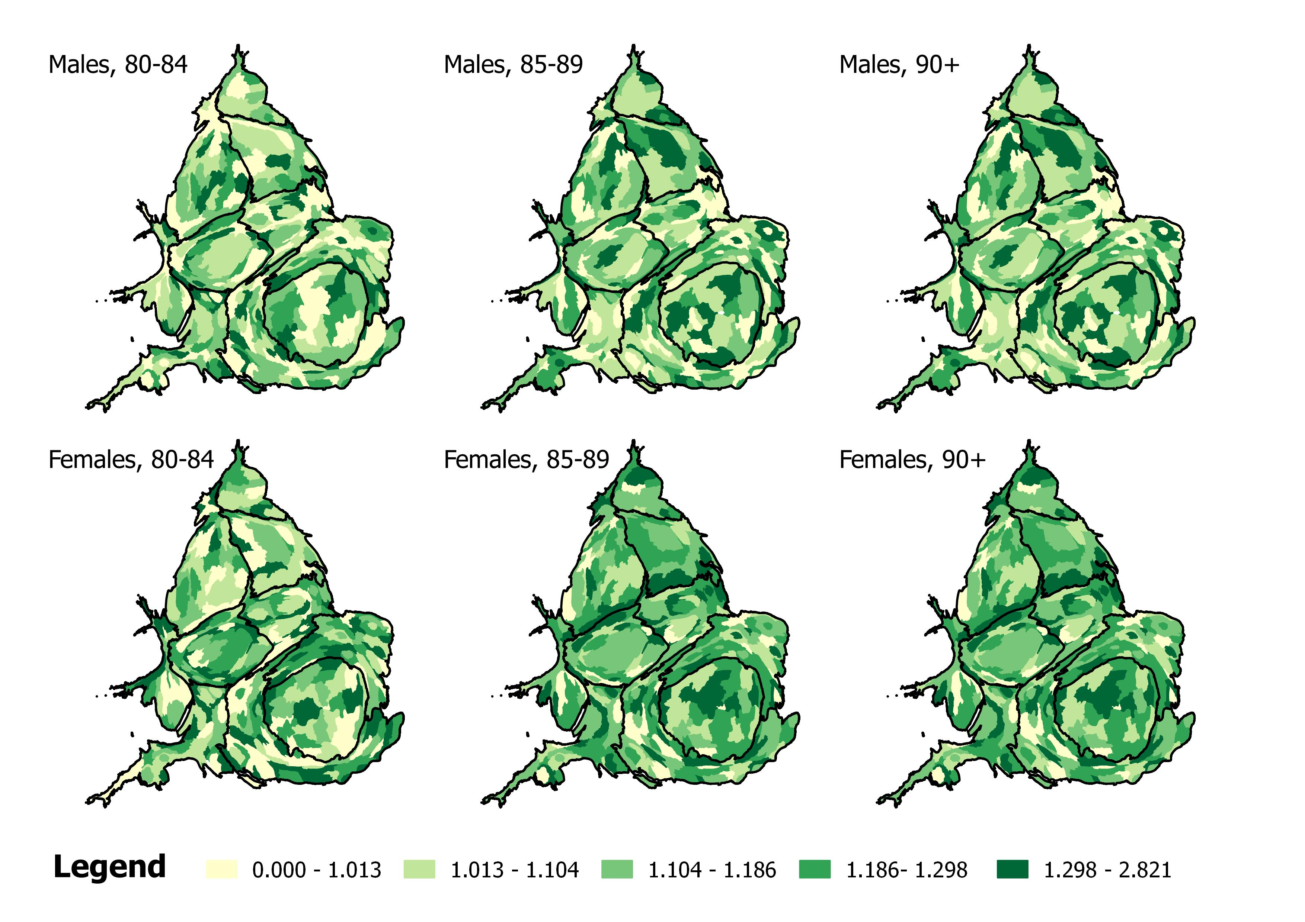

**Figure 3: The relative change in mortality rates by sex and age band for England and Wales, 2014-15 (visualised using cartograms)**

Figures 2 and 3 present standard equal area projection choropleth and cartogram (equal population) choropleth maps, respectively, all of the relative change stratified by age band and sex – all showing where the rises in deaths were greatest for each elderly age and sex group. Whilst not all Local Authorities have experienced increasing mortality rates, most have in at least one of the maps shown in these two figures. There is no spatial patterning to the rises; all types of Local Authorities appear to experiencing this phenomenon. The lack of any spatial patterning was supported by the Moran’s I values, presented in Table 1, demonstrating little evidence of spatial autocorrelation, as well as by exploring the correlation between male and female values by age band (Table 2) and the correlation between age bands within sex (Table 3). Our results show weak to no correlation across our measures, and so no obvious geographical explanation for these rises. This is in great contrast, say, to the rises observed in the late 1960s in England and Wales, which was caused by an influenza epidemic, and spatially patterned accordingly (Hunter and Young, 1971).

**Table 1: Moran’s I values for each age and sex group rate ratio.**

|  |  |  |  |  |  |  |
| --- | --- | --- | --- | --- | --- | --- |
|  | Rate ratio (males) | | | Rate ratio (females) | | |
|  | 80-84 | 85-89 | 90+ | 80-84 | 85-89 | 90+ |
| Moran’s I | 0.042 | 0.021 | -0.003 | 0.001 | -0.024 | -0.022 |

**Table 2: Correlation between age-specific rate ratio values between sex.**

|  |  |
| --- | --- |
| Age band | Correlation between male and female rate ratios |
| 80-84 | 0.157 |
| 85-89 | 0.148 |
| 90+ | 0.129 |

**Table 3: Correlation between age-specific rate ratio values within sex.**

|  |  |  |  |  |  |  |
| --- | --- | --- | --- | --- | --- | --- |
|  | Females | | | Males | | |
| 80-84 | 85-89 | 90+ | 80-84 | 85-89 | 90+ |
| 80-84 | 1 |  |  | 1 |  |  |
| 85-89 | 0.021 | 1 |  | 0.193 | 1 |  |
| 90+ | -0.003 | 0.011 | 1 | 0.122 | 0.064 | 1 |

We also analysed the association of these changes to our explanatory factors (Table 4). For each of our measures, we only find weak correlations suggesting that these relative changes in mortality rates were unrelated to migratory patterns or deprivation. We also examined other Local Authority summary measures of IMD, however they did not alter the findings (results not shown).

**Table 4: Factors correlated with the rate ratio change.**

|  |  |  |  |  |  |  |
| --- | --- | --- | --- | --- | --- | --- |
| Variable | Rate ratio (males) | | | Rate ratio (females) | | |
| 80-84 | 85-89 | 90+ | 80-84 | 85-89 | 90+ |
| Net internal migration of age group | 0.017 | -0.037 | -0.146 | 0.020 | -0.025 | -0.032 |
| Net international migration of age group | 0.019 | -0.021 | 0.081 | -0.026 | -0.040 | 0.065 |
| Mean deprivation score in Local Authority | -0.031 | 0.009 | 0.106 | -0.024 | 0.006 | 0.087 |

*Trends in relative changes of mortality rates for England and Wales, 2003-15*

Each of our sex-specific age band measures were summarised in Figure 4 to explore the overall extent of the relative mortality changes. We also calculated the measure for relative changes between 2013 and 2014. Once again there is no spatial patterning to be seen in either the equal area maps or equal population cartograms. It is clear that what has happened has occurred everywhere. The main difference between the maps over time is the sudden change in the experiences of almost all Local Authorities by 2015. In 2013-14, 4.3% of Local Authorities were categorised in the top group (‘3+ subgroups with relative changes 15%+’) compared to 60.9% in 2014-15. In 2013-14, 27.9% were on the bottom category (‘None of the categories’) whereas in 2014-15 there was only one Local Authority (the ‘City of London’) in this category. We did find evidence of negative correlation for values between years (Table 5). Local Authorities with higher rate ratios in 2013-14 were associated with lower rate ratios in 2014-15. In other words it is possible that in those areas where many frail elderly people did survive through the year to July 2014, fewer then survived in 2015. The year to July 2014 was not a good year for mortality, but it was not unusually bad. The year to July 2015 was exceptionally bad and the early years (2012 and 2013) were also very poor for mortality among the elderly, but not as devastating as 2015 was. Before this period mortality had almost always falling among the old in England and Wales, decade after decade (ONS 2015a and 2015b).

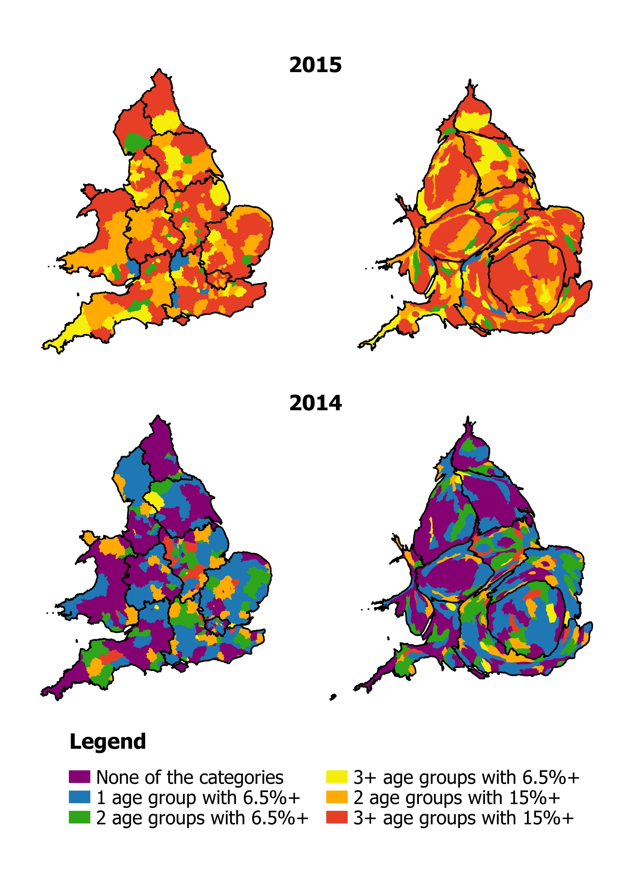

**Figure 4: Categorising the extent of relative mortality changes in England and Wales, 2013-14 and 2014-15.**

**Table 5: Correlation between the age-specific rate ratios for 2013-14 and 2014-15.**

|  |  |  |
| --- | --- | --- |
| Age Band | Males | Females |
| 80-84 | -0.290 | -0.201 |
| 85-89 | -0.243 | -0.403 |
| 90+ | -0.457 | -0.517 |

We extended our categories back to 2003 and present the prevalence of each category in Figure 5. It is clear that the 2014 period was an outlier with a lower relative changed compared to previous years (in other words, ‘things’ did not get much worse in 2014). This will have contributed slightly to the large relative change in mortality rates in 2015. However, Figure 5 still shows that the changes observed in 2015 were of a higher magnitude compared to earlier trends (e.g. the mean percentage of areas with ‘3+ age groups with 15%+’ prior to 2014 was 16.5%). Ignoring 2014, the highest category has grown annually since 2010, the period characterised by austerity.

Figure 6, which summarises a number of self-reported health measures over time within the UK, shows that this was also the period in which progressively more of the population reported that their health was getting worse, year on year every year. The increases in deaths followed the UK-wide worsening in self-reported health with a lag of around two years. Most people reporting worse health will be elderly. The most recent rise in ill health was reported in March 2016 and is not included in the graphs shown in Figure 6 because it was not disaggregated (Dorling 2016b). In 2014, many people in Britain were reporting worse self-reported health than since these self-reported health statistics were first recorded in 2002. Within a year, the greatest rise in mortality for many decades took place.

**Figure 5: Relative changes in mortality rates of Local Authorities in England and Wales, 2003-2015.**

**Figure 6: Trends in self-reported health used by ONS in annual well-being reporting**

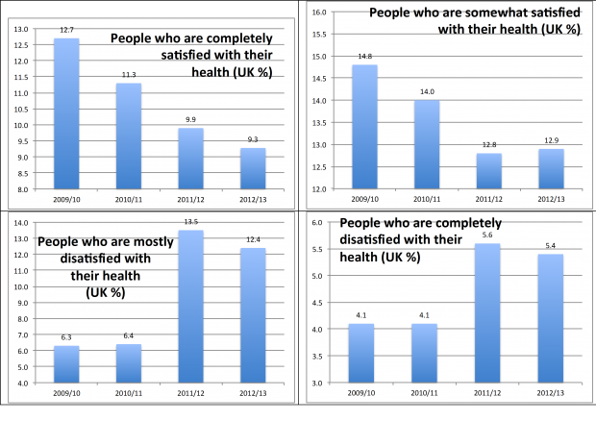

*Source Dorling and Thomas, 2016.*

**Discussion**

In England and Wales there were 39,074 more deaths in 2015 as compared to 2014. The size of the rise was almost directly proportional to age – the frailer an age group was, the greater the proportional rise in mortality was for that group. The geography of this change in mortality rates appears consistent across space – the effects are being felt everywhere; affluent and deprived areas, urban and rural regions, the North and South. The size, scale and lack of geography of these changes in 2015 (particularly in comparison to previous years) suggests that something wider is occurring at the population level.

England & Wales are not alone in seeing increased mortality risks in 2015. Increases have also reported in Scotland (ONS 2016b), France (National Institute of Statistics and Economic Studies 2016), Spain (Instituto Nacional de Estadistica 2016), Denmark (Statistics Denmark 2016) and Switzerland (Swiss Statistics 2016). But the level of increase in England & Wales seems particularly high and is only comparable to those that took place in Scotland that are higher still than in England and Wales (Dorling 2016c).

So what are the possible explanations for such a distinct reversal in mortality rates? It is possible that the effect size is random – mortality rates jump around from year to year – but typically they have continued to fall year on year with the rate of the fall itself changing. The difference between 2014 and 2015 was larger than any previously seen for at least four decades, and combined with the fact that increases have been consistent geographically it would not seem plausible that this is influenza as influenza both spread geographically and increases deaths in a few weeks rather than over many months (Flemming and Elliot, 2008, Figure 2). Mortality rates have not spiked as much since the 1951 and 1968 influenza epidemics[4], and each epidemic displayed a distinct geography unlike in 2015 (Jackson et al. 2010). It is true that mortality rates for respiratory causes increased in 2015 (ONS 2016a). Whilst 2015 experienced a flu virus strain that had greater prevalence in the elderly, levels were described by Public Health England as ‘moderate’ suggesting it is not the sole or even a substantial cause of the most recent rise in deaths among the elderly in England and Wales (Public Health England 2015).

The ONS attributes the increase in old age mortality rates to increases in deaths due to Dementias and Alzheimer’s disease (particularly in comparison to other causes of death) (ONS 2016b). Exploring whether the geography of the relative change in Dementias and Alzheimer’s disease match the geography we report will be necessary to understand why these increases have occurred. However, this explanation is confounded by efforts by the Department of Health to increase the diagnoses of these conditions (Department of Health 2015; ONS 2016b). The increase in these deaths may be capturing better diagnoses, as opposed to a wider population phenomenon, which may explain the increase in mortality rates for these causes. However, what we also need to ask is why people suffering from these two conditions are dying in greater number than before and not surviving for as long as they had been before. Could there be rising problems in social care and with the NHS itself providing crisis care?

An alternative explanation may be that we are starting to see the effects of an ageing population. It is plausible that social and medical progress has prolonged the lives individuals who would have otherwise died earlier, and the jump in mortality rates are these individuals now reaching a point where further survival is harder to sustain. We may also be starting to see a plateau of potential human longevity, but many other affluent countries have far higher life expectancies than the UK does, and the UK has been falling in the international rankings in recent decades. The explanation, that we are seeing a growing elderly cohort being prolonged into very old age, would also feed into the increase in Dementias and Alzheimer’s disease, as well as the population ageing as part of the explanation argument. However, whilst the largest increases in mortality rates have been experienced in the oldest age groups, Figure 1 demonstrates that most age bands have seen increasing mortality rates suggesting that it is not just an increase in very elderly people. Furthermore, if this was the case then we would have expected a gradual increase in the trend as opposed a sudden jump across each of our age bands. We also adjust our estimates for age to account for any compositional changes in the average age within strata.

, coincident with the rises we report and map in this paper, We think it likely that the rises in death rates are consequences of under-investment (possibly combined with mis-investment) in healthcare and social care in recent years, and in particular within the NHS. Longevity has been rising in the affluent world for over 100 years, and in most of the world for more than 50, but with this rising longevity has come rising age-related multimorbidity, leading to ever rising healthcare and social care costs. Where rising expenditure on healthcare and social care for elderly people falls short of rising need, increasing elderly mortality can be expected.

Even individuals who are not directly affected may be indirectly impacted through stress and anxiety of the wider political system. Smaller changes to social provisions (e.g. bus services being cut, ‘chit and chat’ groups disappearing, libraries being shut) may accumulate in their ‘burden’. Such changes have occurred everywhere. Given that the whole of Europe has experienced austerity to some degree, it would appear to be a consistent (geographical) factor that could explain the increases in mortality rates both across England and Wales, as well as Europe. Furthermore we must consider wider explanations. Austerity has mainly hit the young and poor. This includes people who work in old age homes who may now also have to take a second job, say, driving taxis at night. Could we be seeing the effects of austerity on one age group – the young – having its most obviously impact on another age group – the old. When the old become frail a “triple-lock” on their pensions could be of very little protection in a society in which the social services that the old most rely on are being cut away.

The move to an austere society appears to have had a relatively quick and unambiguous effect on mortality in the elderly in England and Wales, but the overall effects on health for younger people may be lagged, and take decades to be properly understood. Immediately following the Great Recession, suicide rates in the USA rose (Barr et al. 2012); a similar rise in suicides in the USA, for middle-aged White Non-Hispanics was observed following the 2008 recession [Case Deaton; Minton IJE], but the same data also revealed sharp falls in vehicle related deaths in young adults of all ethnicities, and falls in rates of violent death in Black males. [Minton, IJE]. The slight falls in mortality rates we identified for both young adults and young children, along with evidence that road injuries fell from 10th to 16th place as a leading cause of years of life lost (YLL) in England from 2008 to 2013, suggests that in the short run, austere societies can reduce rather than increase mortality risks at some ages. However, recent research on suicide trends in Scotland suggests that the mortality effects of socioeconomic change may, in the UK rather than the USA, be largely cohort rather than period effects, disproportionately affecting working age males from more socioeconomically deprived areas who first entered the labour market after the wide-reaching reforms of the Thatcher government had been enacted. Similar cohort effects in drug-related deaths have also been identified. Population level trends in mortality usually respond to societal changes slowly since their causes often take a long time to take effect (Musterd et al. 2012). Similar lag effects during this period have been witnessed with food bank usage (Lambie-Mumford & Green 2015) and homelessness (Loopstra et al. 2015). What is most shocking about the small rises in elderly mortality in 2012 and 2013 (Dorling, 2014) and the large rise in 2015 (Dorling 2016d) is just how fast the ‘dose-response’ effect appears to have been at these vulnerable ages.

There are several limitations to our study. Our analyses are fairly descriptive and are limited in their ability to explore and explain the underlying causes of the increasing mortality rates. Future research will need to examine additional factors associated with the increase in mortality rates. There were no publically data available on deaths by cause, limiting our ability to understand what causes were driving the increases in mortality rates by Local Authority. The scale of our analysis is the Local Authority level and this may hide some small level geographical patterns that might reveal more. Exploring the spatial distribution at smaller geographies will be key to helping us understand what factors are associated with these changes.

**Conclusion**

Separating out distinct causal factors to understand population level trends is almost always inherently difficult. Multiple forms of fiscal cut have occurred in the UK in recent years, each of which could have been an independent cause of harm. We offer possible explanations for our findings, although the truth is likely to lie somewhere in the middle of them, and if austerity is the main factor it might well have been the effect on the young and how that somehow then altered the life chance of the old and especially the very elderly. What is definite is that our findings demonstrate unprecedented changes in a time of no war, no great influenza epidemic, no freezing winter, and no cholera, with rising mortality rates amongst the elderly with no clear geographical pattern. Decades of progress in population health, with falling mortality rates becoming the norm, have been reversed, and the magnitude of this change and the small rises in 2012 and 2013 suggests that 2015 is not an isolated event. The implications of these changes are profound given what has come before them, combined with the current political climate. What is troubling is that the marked rise does not appear to have been raised as unusual or picked up in the media[5]. Buy what is clear is that the size and scale of the increase cannot be ignored. Mostly people who get to live to very old ages had quite a confortable life. The majority of today’s elderly were the middle class of a generation ago. If life for the elderly is getting worse, this is what we should expect for our own lives, for people who read and write papers in journals such as this.

**References**

Barr, B. et al., 2016. “First, do no harm”: are disability assessments associated with adverse trends in mental health? A longitudinal ecological study. *Journal of Epidemiology & Community Health*, 70, pp.339–345.

Barr, B. et al., 2012. Suicides associated with the 2008-10 economic recession in England : time trend analysis. *BMJ*, 345, p.e5142.

Barr, B., Kinderman, P. & Whitehead, M., 2015. Trends in mental health inequalities in England during a period of recession, austerity and welfare reform 2004 to 2013. *Social Science & Medicine*, 147, pp.324–331. Available at: http://dx.doi.org/10.1016/j.socscimed.2015.11.009.

Case, A. & Deaton, A., 2015. Rising morbidity and mortality in midlife among white non-Hispanic Americans in the 21st century. *PNAS*, 112(49), pp.15078–15083.

Department of Health, 2015. A mandate from the Government to NHS England: April 2015 to March 2016. Available at: https://www.gov.uk/government/uploads/system/uploads/attachment_data/file/486818/mndate-NHSE-15_16.pdf.

Dorling D. (2014) Why are the old dying before their time? How austerity has affected mortality rates. New Statesman 2014 Feb 7. http://www.newstatesman.com/politics/2014/02/why-are-old-people-britain-dying-their-time

Dorling, D. (2016a) A Better Politics: How Government Can Make Us Happier, with illustrations by Ella Furness, London: London Publishing Partnership

Dorling, D. (2016b) Austerity, Rapidly Worsening Public Health across the UK, and Brexit, Political Insight Blog, Political Studies Association, July 11th, https://www.psa.ac.uk/insight-plus/blog/austerity-rapidly-worsening-public-health-across-uk-and-brexit-0

Dorling, D. (2016c) Dorling, D. (2016) The Scottish Mortality Crisis, The Geographer, (Newsletter of the Royal Scottish Geographical Society), Summer, pp.8-9.

Dorling, D. (2016d) Rapid Response: Editorial - Brexit: the decision of a divided country, BMJ, August 1st, http://www.bmj.com/content/354/bmj.i3697/rr-3

Dorling, D. and Thomas, B. (2016) People and Places, A 21st century Atlas of the UK, Bristol: Policy Press

Dunn, P., McKenna, H. & Murray, R., 2016. Deficits in the NHS 2016. Available at: http://www.kingsfund.org.uk/publications/deficits-nhs-2016.

Fleming, D.M. and Elliot, A.J. (2008) Lessons from 40 years’ surveillance of influenza in England and Wales, Epidemiol. Infect., 136, 866–875. doi:10.1017/S0950268807009910

Garrett, E., Galley, C., Shelton N. and Woods, R. (eds), Infant Mortality: A Continuing Social Problem A volume to mark the centenary of the 1906 publication of Infant Mortality: A Social Problem by George Newman, Aldershot: Ashgate.

Gelman, A. & Auerbach, J., 2016. Age-aggregation bias in mortality trends. *PNAS*, 113(7), pp.816–817.

Hunter J.M. and Young, J.C. (1971) Diffusion of Influenza in England and Wales, Annals of the Association of American Geographers, 61, 4, 637-653

Instituto Nacional de Estadistica, 2016. Vital Statistics. Provisional data: Year 2015. Available at: http://www.ine.es/dynt3/inebase/en/index.htm?type=pcaxis&path=/t20/e301/provi&file=pcaxis.

Jackson, C. et al., 2010. Original Contribution Estimates of the Transmissibility of the 1968 (Hong Kong) Influenza Pandemic: Evidence of Increased Transmissibility Between Successive Waves the ability of novel influenza viruses to spread rapidly but shared its neuraminidase wi. *American Journal of Epidemiology*, 171(4), pp.465–478.

Lambie-Mumford, H. & Green, M.A., 2015. Austerity , welfare reform and the rising use of food banks by children in England and Wales. *Area*, pp.1–7.

Loopstra, R. et al., 2015. The impact of economic downturns and budget cuts on homelessness claim rates across 323 local authorities in England, 2004 – 12. *Journal of Health Services Research & Policy*, pp.1–9.

Loopstra, R.,McKee, M., Katikireddi, S.V., Taylor-Robinson, D., Barr, B. and Stuckler, D. (2016) Austerity and old-age mortality in England: a longitudinal cross-local area analysis, 2007–2013, J R Soc Med.,109(3): 109–116, doi: 10.1177/0141076816632215

Minton, J. et al., 2016. Two cheers for a Small Giant? Why we need better ways of seeing data. A commentary on: “Rising morbidity and mortality in midlife among white non-Hispanic (WNH) Americans in the 21st century.” *International Journal of Epidemiology*.

Minton, J., Vanderbloemen, L. & Dorling, D., 2013. Visualizing Europe’s demographic scars with coplots and contour plots. *International Journal of Epidemiology*, 42, pp.1164–1176.

Moffatt, S. et al., 2015. A qualitative study of the impact of the UK “bedroom tax.” *Journal of Public Health*, 38(2), pp.197–205.

Moran, P.A.P., 1950. Notes on Continuous Stochastic Phenomena. *Biome*, 37(1/2), pp.17–23.

Musterd, S., Galster, G. & Andersson, R., 2012. Temporal dimensions and measurement of neighbourhood effects. *Environment and Planning A*, 44, pp.605–627.

National Institute of Statistics and Economic Studies, 2016. Demography - Number of deaths - Metropolitan France. Available at: http://www.insee.fr/en/bases-de-donnees/bsweb/serie.asp?idbank=000436394.

Omran, A.R., 1971. The Epidemiological Transition: A Theory of the Epidemiology of Population Change. *The Milbank Quarterly*, 49(4), pp.509–538.

ONS, 2016a. Deaths registered in England and Wales: 2015. Available at: https://www.ons.gov.uk/peoplepopulationandcommunity/birthsdeathsandmarriages/deaths/bulletins/deathsregistrationsummarytables/2015#deaths-increase-in-2015.

ONS, 2014. Life Expectancy at Birth and at Age 65 by Local Areas in the United Kingdom: 2006-08 to 2010-12. Available at: http://www.ons.gov.uk/peoplepopulationandcommunity/birthsdeathsandmarriages/lifeexpectancies/bulletins/lifeexpectancyatbirthandatage65bylocalareasintheunitedkingdom/2014-04-16.

ONS (2015a) England and Wales Population Estimates 1838 to 2014: https://www.ons.gov.uk/peoplepopulationandcommunity/populationandmigration/populationestimates/adhocs/004358englandandwalespopulationestimates1838to2014

ONS (2015b) Vital Statistics: Population and Health Reference Tables: http://www.ons.gov.uk/peoplepopulationandcommunity/populationandmigration/populationestimates/datasets/vitalstatisticspopulationandhealthreferencetables

ONS, 2016b. Provisional analysis of death registrations: 2015.

Public Health England, 2015. Surveillance of influenza and other respiratory viruses in the United Kingdom : winter 2014 to 2015. Available at: https://www.gov.uk/government/uploads/system/uploads/attachment_data/file/429617/Annualreport_March2015_ver4.pdf.

Statistics Denmark, 2016. Deaths. Available at: http://www.dst.dk/en/Statistik/emner/doedsfald-og-middellevetid/doedsfald.

Stuckler, D. et al., 2011. Effects of the 2008 recession on health: a first look at European data. *Lancet*, 378, pp.124–125.

Swiss Statistics, 2016. Components of population change - Data, indicators. Available at: http://www.bfs.admin.ch/bfs/portal/en/index/themen/01/06/blank/key/04.html.

Tobler, W., 2004. Thirty Five Years of Computer Cartograms. *Annals of the Association of American Geographers*, 94(1), pp.58–73.

Woolf, S.H. et al., 2007. Giving Everyone the Health of the Educated : An Examination of Whether Social Change Would Save More Lives Than Medical Advances. *American Journal of Public Health*, 97(4), pp.679–683.

1. Data are available here: <https://www.ons.gov.uk/file?uri=/peoplepopulationandcommunity/populationandmigration/populationestimates/datasets/populationestimatesforukenglandandwalesscotlandandnorthernireland/mid2015/ukmye2015.zip>
2. We refer to all ‘London Boroughs’, ‘Districts’ and ‘Unitary Authorities’ collectively as Local Authorities since this is how they are referred to by the ONS.
3. Using the non-adjusted age-specific rates did not alter the findings, suggesting that age-aggregation bias was not an important factor.
4. The increase in mortality rates in both 1951 and 1968 was still lower than that witnessed in 2015.
5. The Office for National Statistics released the data at 10am on June 23rd 2016, the morning of the day of the EU referendum. There was no press release because of the vote.